EXPERIMENT – 15 Create a Snapshot of a VM and Test it by loading the Previous Version/Cloned VM using Vmware workstation.

Aim:

To create a snapshot of a virtual machine and test it by reverting to the previous state/cloned VM using VMware Workstation.

Procedure:

1. Open VMware Workstation and power on the desired virtual machine.
2. Configure and run the VM until it reaches the state you want to save.
3. From the menu bar, go to VM → Snapshot → Take Snapshot.
4. Enter a name and description (e.g., “Before software installation”).
5. Click Take Snapshot to save the current state of the VM.
6. Make some changes inside the VM (e.g., install/uninstall software, edit files).
7. To test, go to VM → Snapshot → Revert to Snapshot.
8. The VM will reload the previous saved version, discarding the recent changes.
9. Alternatively, you can use Snapshot Manager to manage, restore, or clone snapshots.
10. Verify that the system successfully returns to the saved state.

Output:

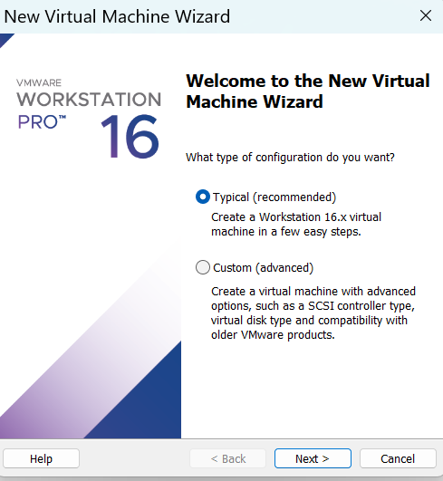

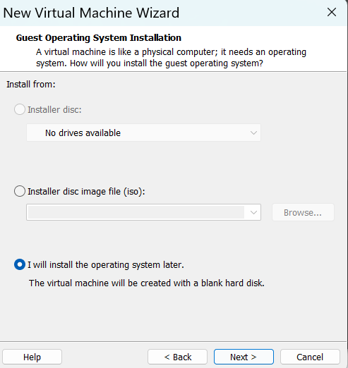

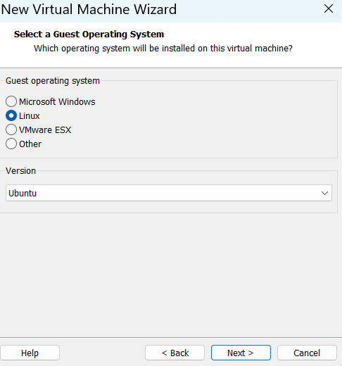

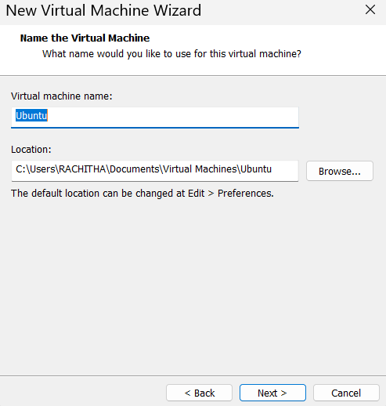

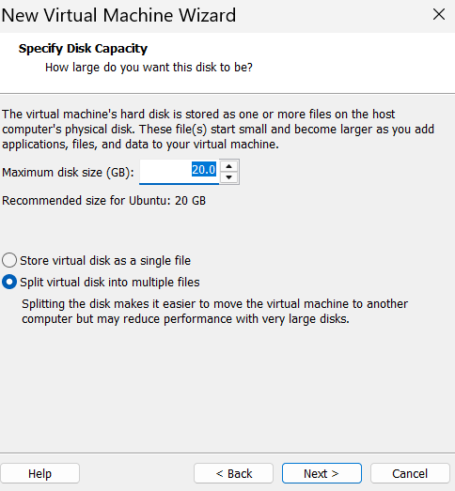

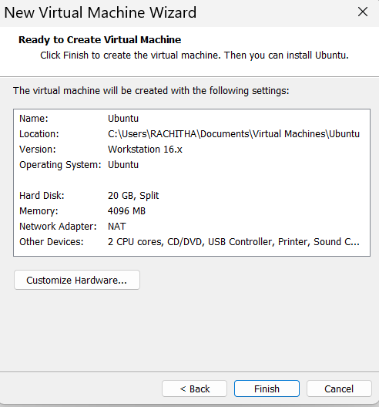

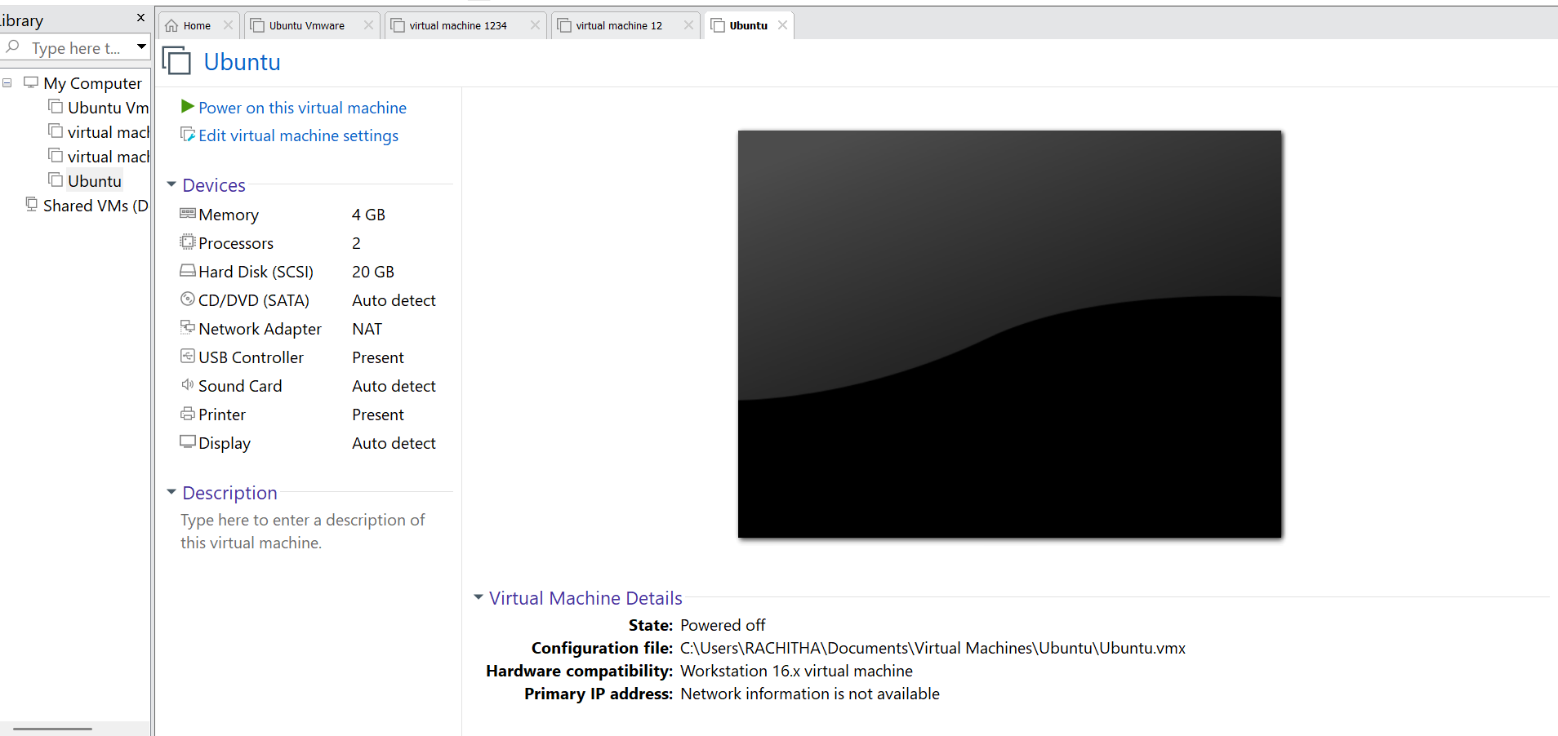

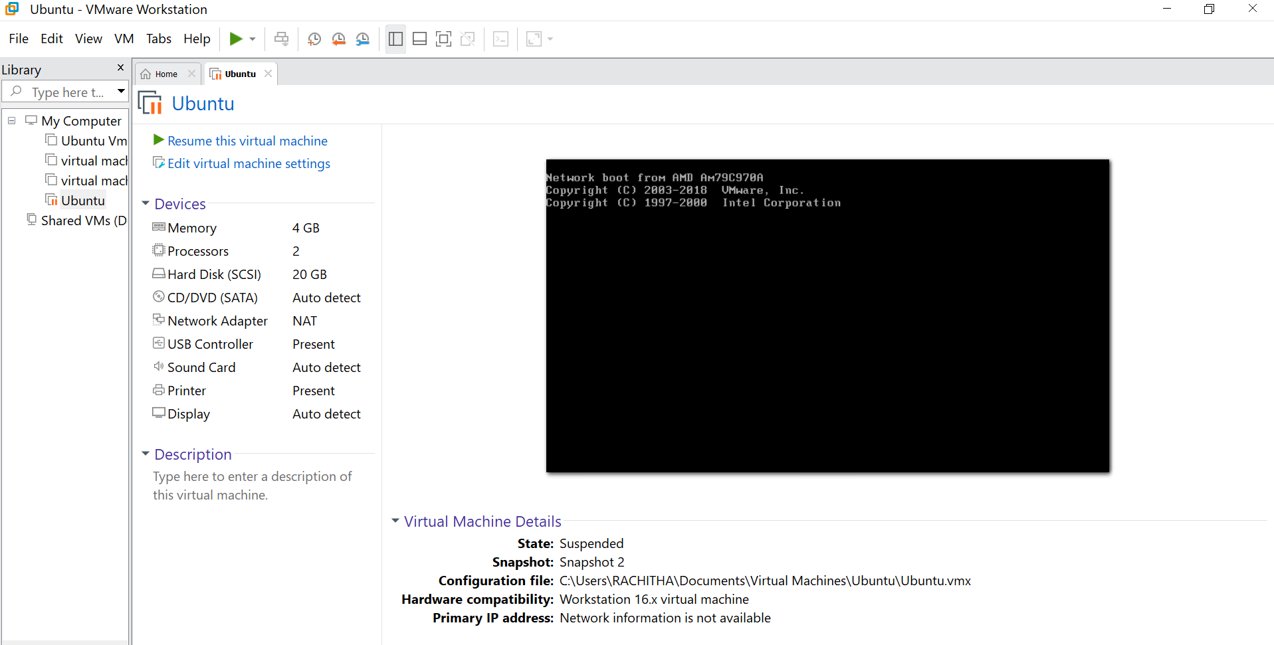

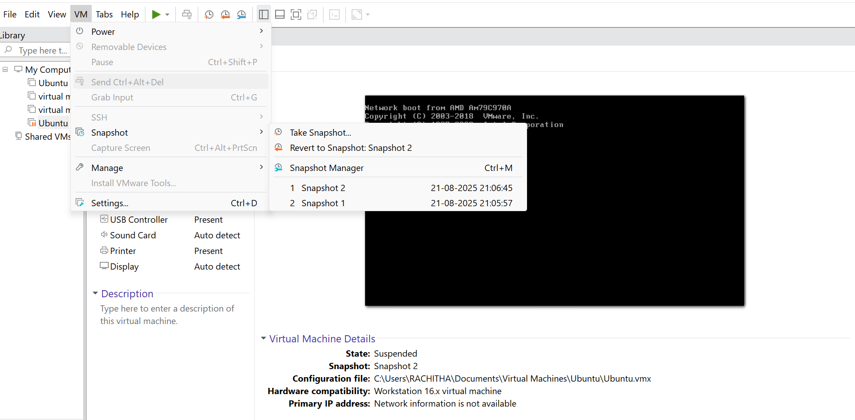

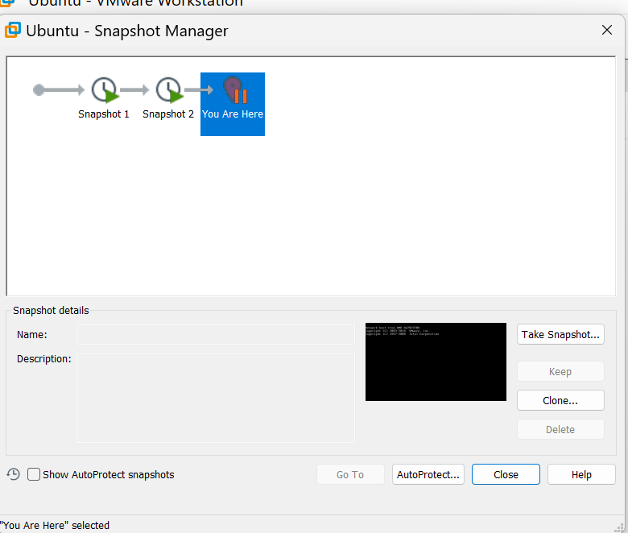

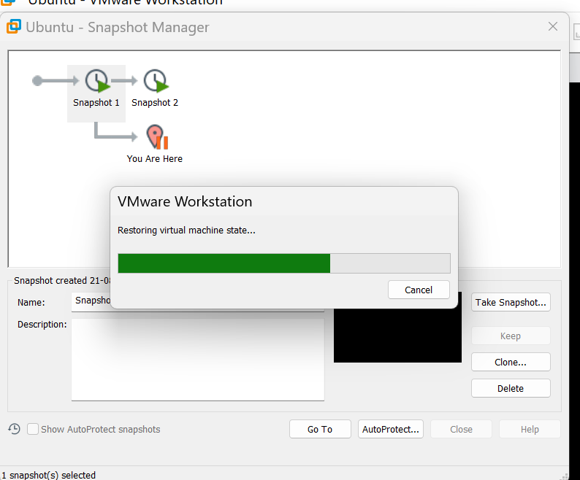

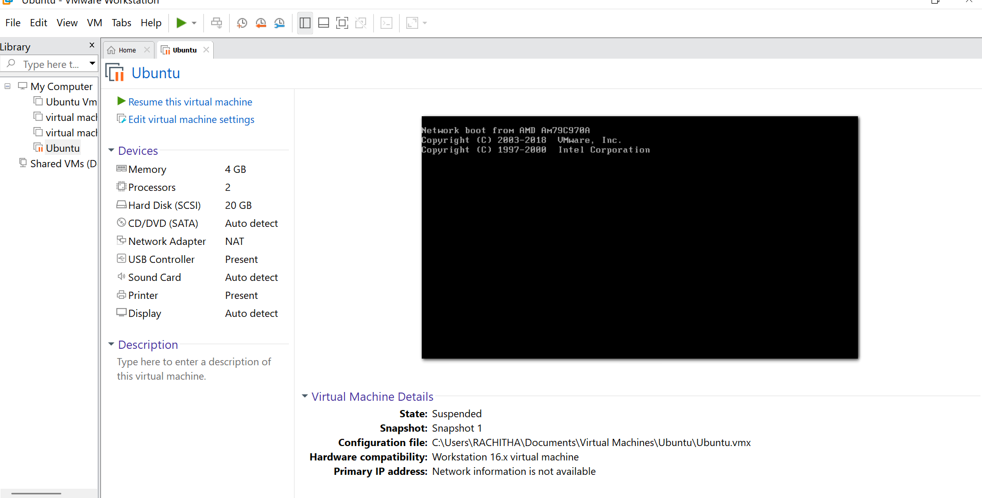

Result:

A snapshot of the VM was successfully created and tested by reverting to the previous version using VMware Workstation. The VM restored its earlier state, demonstrating snapshot and cloning functionality.